PROJECT REPORT

**IBM-Project-34737-1660275704**

# TITLE:

***Skill / Job Recommender Application***

# TEAM LEADER:

CHAAMUNDESWARAR J

# TEAM MEMBER:

* AJITH KUMAR R
* CHANDRU V
* RANJITH KUMAR S
* VISHAAL J

# TEAM ID:

PNT2022TMID07820

1

|  |  |
| --- | --- |
| **TABLE OF CONTENTS** | **PAGE NO** |
| 1. **INTRODUCTION**  Project Overview Purpose | **4-5** |
| 2. **LITERATURE SURVEY**  Existing problem References  Problem Statement Definition | **6-9** |
| 3. **IDEATION & PROPOSED SOLUTION**  Empathy Map Canvas Ideation & Brainstorming Proposed Solution Problem Solution fit | **10-13** |
| 4. **REQUIREMENT ANALYSIS**  Functional requirement  Non-Functional requirements | **14** |
| **5. PROJECT DESIGN**  Data Flow Diagrams  Solution & Technical Architecture User Stories | **15-16** |
| **6. PROJECT PLANNING & SCHEDULING**  Sprint Planning & Estimation Sprint Delivery Schedule Reports from JIRA | **17-20** |
| **7. CODING & SOLUTIONING**  Feature 1  Feature 2 | **20-21** |
| **8. TESTING**  Test Cases  User Acceptance Testing | **22** |

|  |  |
| --- | --- |
| **9. RESULTS**  9.1 Performance Metrics | **23** |
| **10. ADVANTAGES & DISADVANTAGES** | **23-24** |
| **11. CONCLUSION** | **24** |
| **12.FUTURE SCOPE** | **25** |
| **13. APPENDIX** | **25-36** |

## INTRODUCTION

**Project Overview**

Job recommendation is an important task for the modern recruitment industry. An excellent job recommender system not only enables to recommend a higher paying job which is maximally aligned with the skill-set of the current job, but also suggests to acquire few additional skills which are required to assume the new position.

In this work, we created three types of information networks from the historical job data: (i) job transition network, (ii) job-skill network, and (iii) skill co-occurrence network. We provide a representation learning model which can utilize the information from all three networks to jointly learn the representation of the jobs and skills in the shared k-dimensional latent space.

In our experiments, we show that by jointly learning the representation for the jobs and skills,our model provides better recommendation for both jobs and skills. Additionally, we also show some case studies which validate our claim.

To develop an end-to-end web application capable of displaying the current job openingsbased on the user skillset.

The user and their information are stored in the Database. An alert is sent when there is anopening based on the user skillset.

Users will interact with the chatbot and can get the recommendations based on their skills.We can use a job search API to get the current job openings in the market which will fetchthe data directly from the webpage

## Purpose

An excellent job recommender system not only enables to recommend a higher paying job which is maximally aligned with the skill-set of the current job, but also suggests to acquire few additional skills which are required to assume the new position.

To create a software that filters the job based on the skillset of the candidates who are seeking for the job. Then that filtered job is recommended for that candidates based on their skillset.

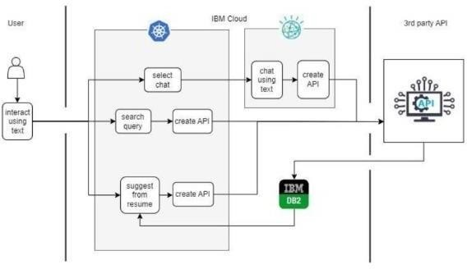

## LITERATURE SURVEY

**Existing problem**

“Job Recommendation based on Job Seeker Skills. Jorge ValverdeRebaza

,Ricardo Puma,Paul Bustios Nathalia C. Silva. : First Workshop on Narrative Extraction From Text co- located with 40th European Conference on Information Retrieval March 2018”.In this ,when a candidate submits his/ her profile at a job seeker engine.Their job recommendations are mostly suggested taking their academic qualification and work experience into considerations.

“A survey of job recommender systems, Shaha Alotaibi ,International Jounal of PhysicalSciences July 2012”. The recommender system technology aims to help users in finding items that match their personnel interests, it has a successful usage in e-commerce applications to deal with problems related to information overload efficiently.This article will present a survey of e-recruiting process and existing recommendation approaches for building personalized recommender systems for candidates/job matching.

A Research of Job Recommendation System Based on Collaborative Filtering: ChengYang,Yingya Zhang,Zhixiang Niu, 2014 Seventh International Symposium on Computational Intelligence and Design, December 2014”

It analyze the candidate’s resume and the companies’ recruitment guidelines.To compare and come to a better conclusion upon finding the best suited candidates for the job.

## References

1. Nikolaos D. Almalis ,Prof. George A. Tsihrintzis Nikolaos Karagianniset al."FoDRA - A New Content-Based Job Recommendation Algorithm for Job Seeking and Recruiting
2. Pazzani M J, Billsus D. Content-based recommendation systems[M]//The adaptive web. Springer Berlin Heidelberg, 2007:325-341.
3. Sarwar B, Karypis G, Konstan J, et al. Item-based collaborative _ltering recommendation

algorithms[C]//Proceedings of the 10th international conference on World Wide Web. ACM, 2001: 285-295.

1. Nikolaos D. Almalis ,Prof. George A. Tsihrintzis , Nikolaos Karagianniset al."FoDRA - A New Content-Based Job Recommendation Algorithm for Job Seeking and Recruiting".
2. Anika Gupta, Dr. Deepak Garg. "Applying Data Mining Techniques in Job Recommender System for Considering Candidate Job Preferences".
3. Dunning T. Accurate methods for the statistics of surprise and coincidence[J]. Computational linguistics, 1993, 19(1): 61-74.
4. Emmanuel Malherbe , Mamadou Diaby , Mario Cataldi et al. "Field Selection for Job Categorization and

Recommendation to Social Network Users". 2014 IEEE/ACM International Conference on Advances in Social Networks Analysis and Mining (ASONAM 2014).

## Problem Statement Definition

Having lots of skills but wondering which job will best suit you? Don’t need to worry!

We have come up with a skill recommender solution through which the fresher or the skilledperson can log in and find the jobs by using the search option or they can directly interact with the chat bot and get their dream job.

To develop an end-to-end web application capable of displaying the current job openingsbased on the user skillset. The user and their information are stored in the Database. An alert is sent when there is an opening based on the user skillset. Users will interact with the chat bot and can get the recommendations based on their skills. We can use a job search APIto get the current job openings in the market which will fetch the data directly from the webpage.

## IDEATION & PROPOSED SOLUTION

**Empathy Map Canvas**

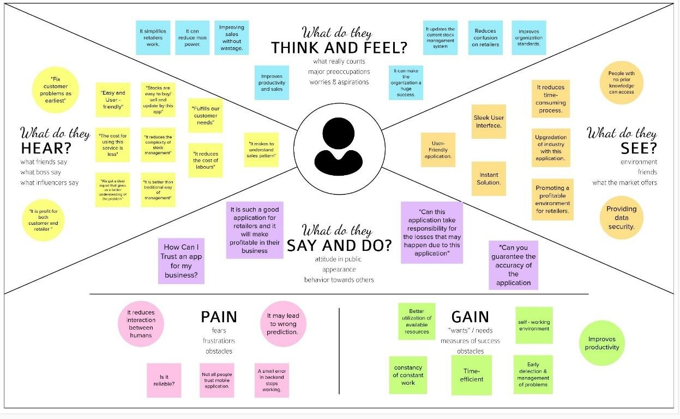

## Ideation & Brainstorming

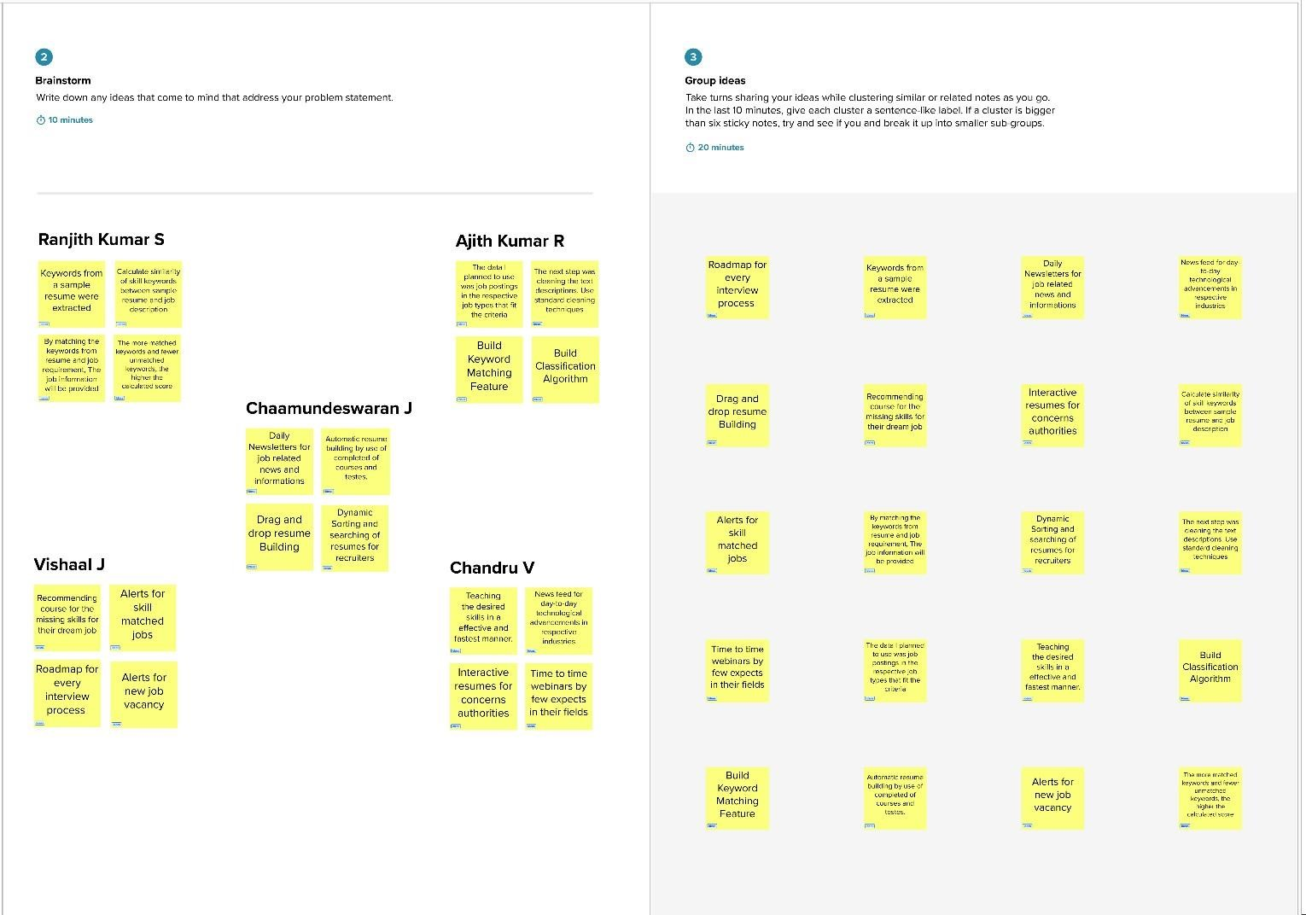

**Proposed Solution**

|  |  |  |
| --- | --- | --- |
| **S.No.** | **Parameter** | **Description** |
| 1. | Problem Statement (Problem to be solved) | These days, many students and job seekers have excellent capabilities but are unable to land the desired or suitable employment. To solve this problem, an end-to-end web application that can present current job vacancies depending on user skill sets can be developed. |
| 2. | Idea / Solution description | To develop an web application which in default have a lot of current job openings through job search API out of which appropriate job will be recommended based on user skill set. At the same time students can develop their skills side by side with various courses and webinars offered by reputed organization. In addition to this a smart chat bot will be available for 24*7 which can help users in finding the right job |
| 3. | Novelty / Uniqueness | A chatbot can easily save time and effort. These chatbot communicate with humans in a very natural form to resolve their queries and to assist them as required. The major challenge is no reply from industry side. In this project user  get notification wheather they accept or reject the  application |
| 4. | Social Impact / Customer Satisfaction | The user allowed to choose the required job as per  his/her skill level. It helps user to make right decision to choose their required field job. |
| 5. | Business Model (Revenue Model) | We can provide the application for job seekers in a subscription based. We can share the profiles with companies and generate the revenue by providing them best profiles. |
| 6. | Scalability of the Solution | In this system, we demonstrate a chatbot that uses Artificial Intelligence to produce dynamic responses to online client enquiries. Data can be scaled up and scaled down according to number of current job openings available. |

## Problem Solution fit

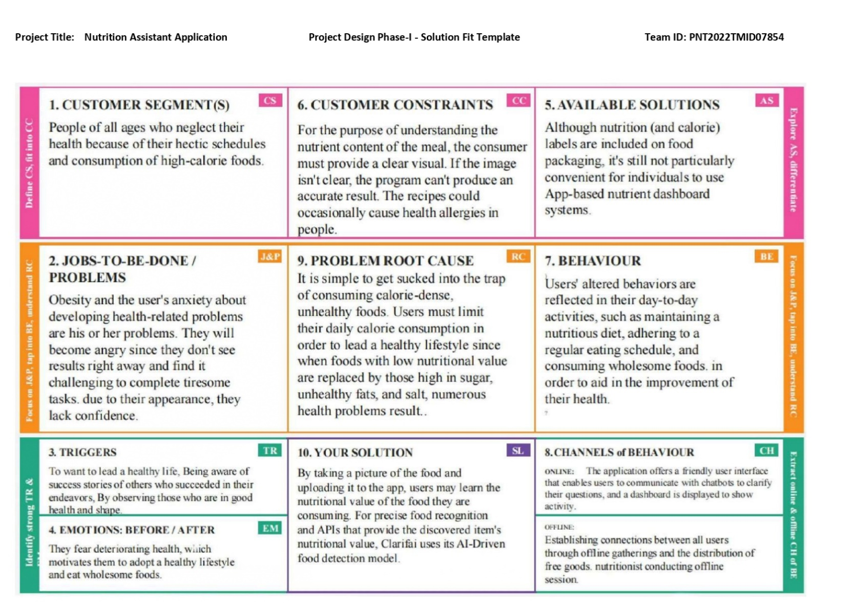

1. **REQUIREMENT ANALYSIS**

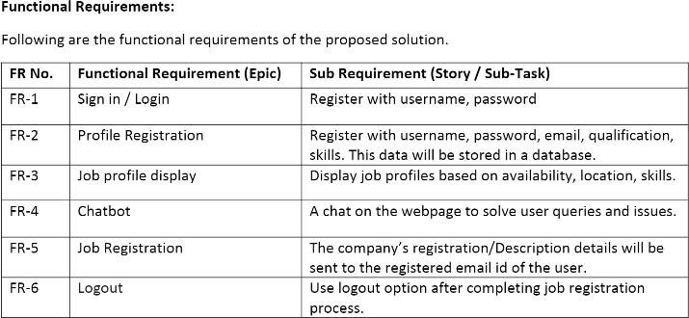

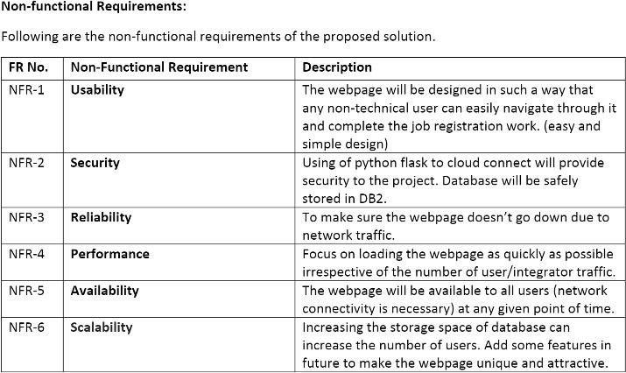

## PROJECT DESIGN Data Flow Diagrams

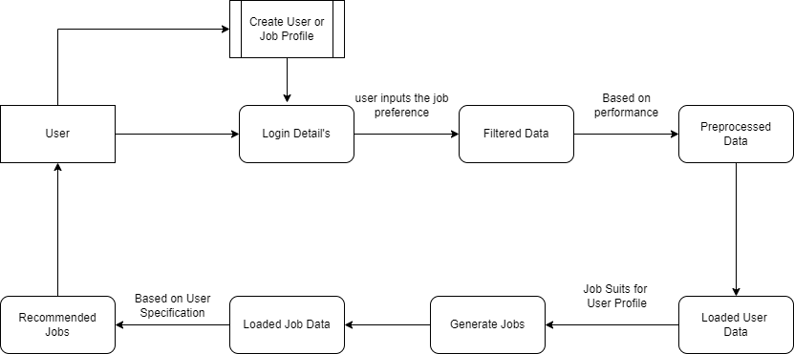

**Solution & Technical Architecture**

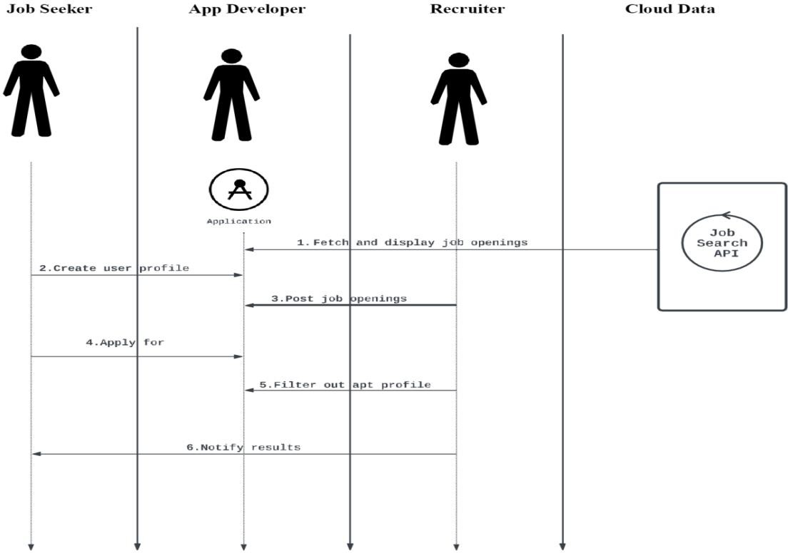



## download (4).pngUser Stories

1. **PROJECT PLANNING & SCHEDULING Sprint Delivery Plan**

**Product Backlog, Sprint Schedule, and Estimation:**

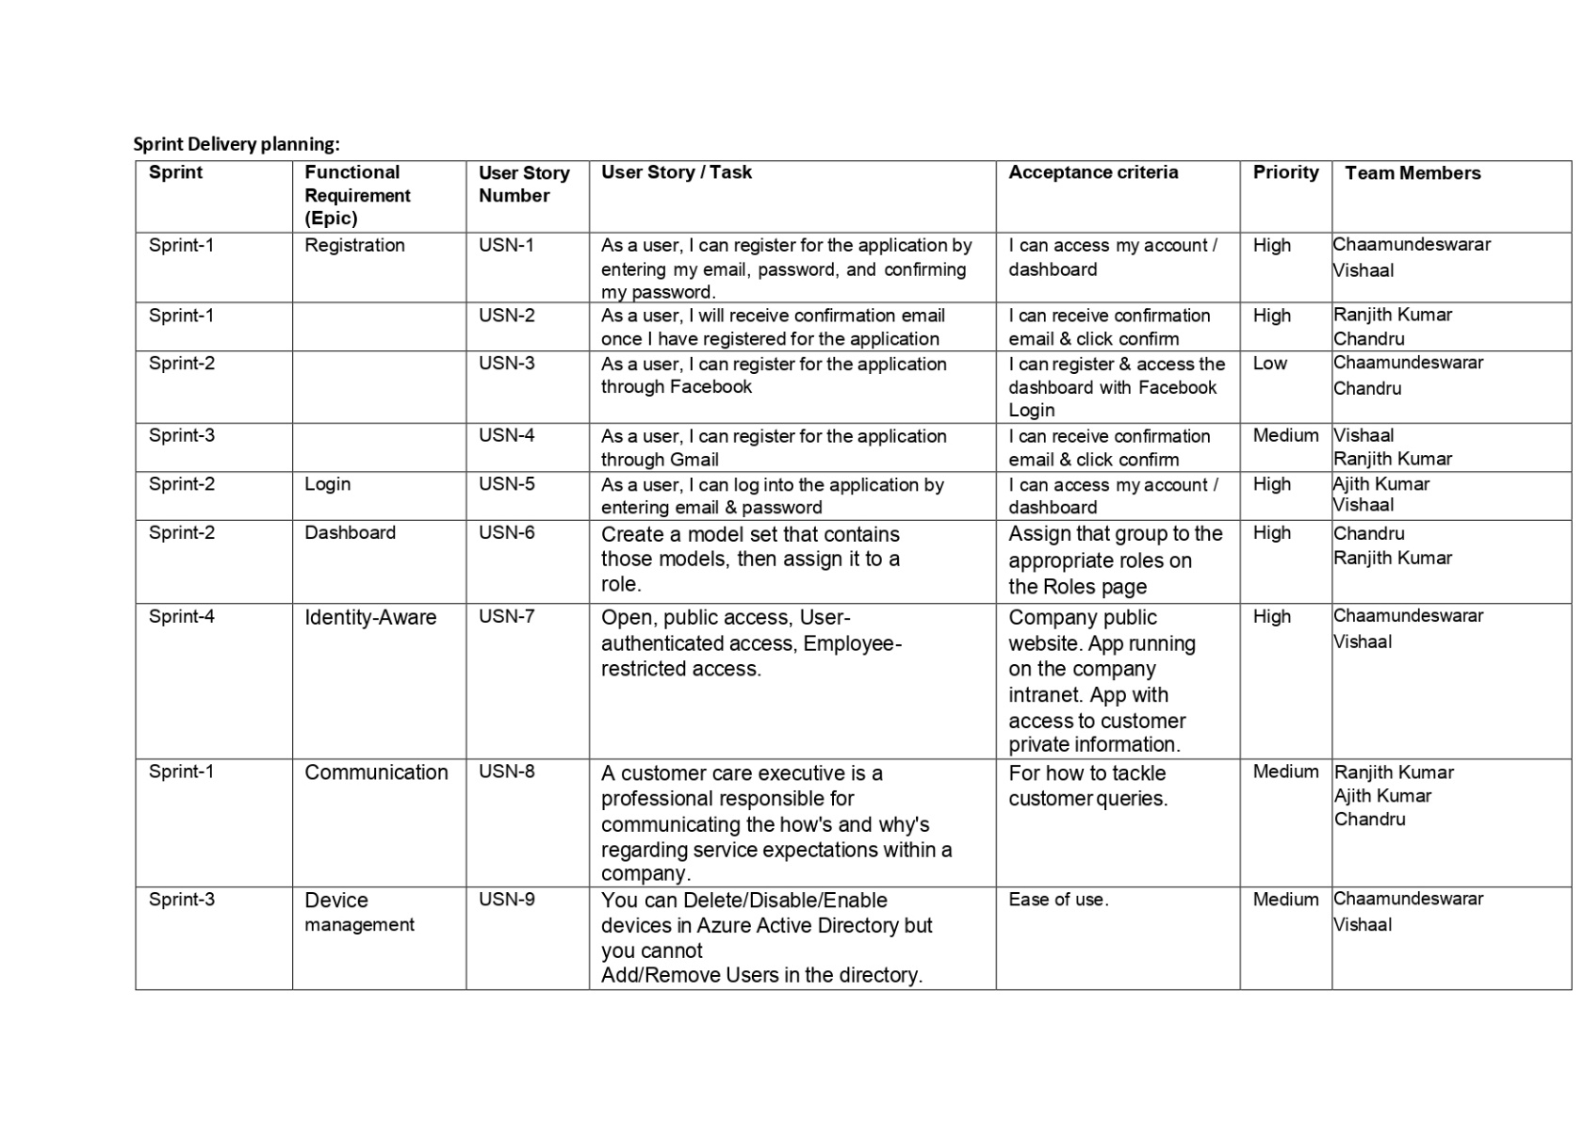

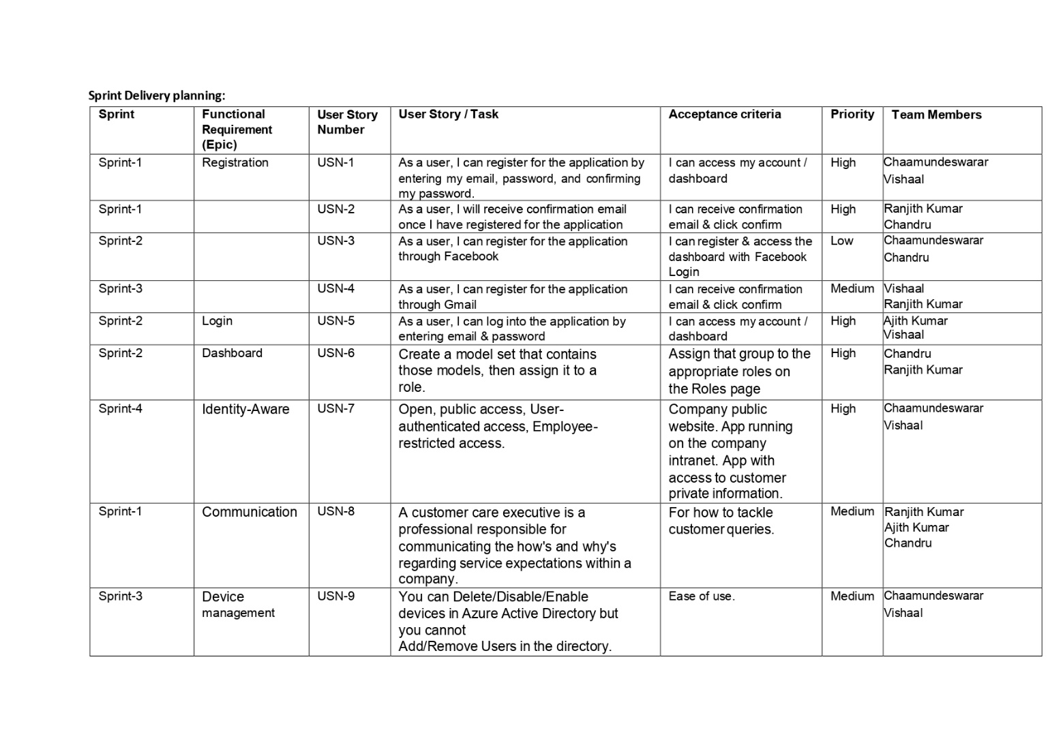

# Project Tracker :

|  |  |  |  |  |  |  |
| --- | --- | --- | --- | --- | --- | --- |
| **Sprint** | **Total Story Points** | **Duration** | **Sprint Start Date** | **Sprint End Date (Planned**  **)** | **Story Points Completed (as on**  **Planned End Date)** | **Sprint Release Date (Actual)** |
| Sprint-1 | 15 | 6 Days | 26 Oct 2022 | 31 Oct 2022 | 15 | 31 Oct 2002 |
| Sprint-2 | 15 | 6 Days | 02 Nov 2022 | 07 Nov 2022 | 15 | 03 Nov 2022 |
| Sprint-3 | 10 | 6 Days | 09 Nov 2022 | 14 Nov 2022 | 15 | 14 Nov 2022 |
| Sprint-4 | 10 | 6 Days | 16 Nov 2022 | 21 Nov 2022 | 15 | 21 Nov 2022 |

download (8).png

**Velocity:**

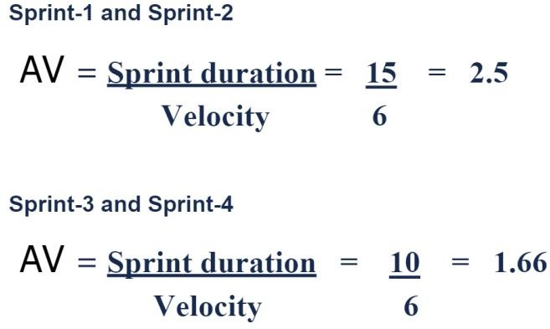

# JIRA FILES :

Road Map

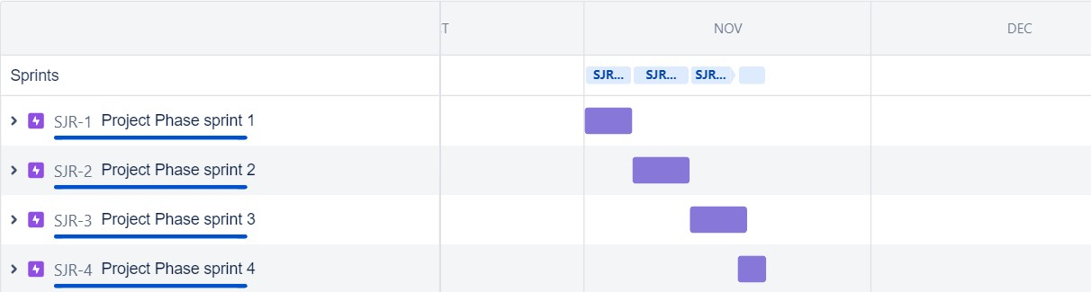

# Burndown Chart

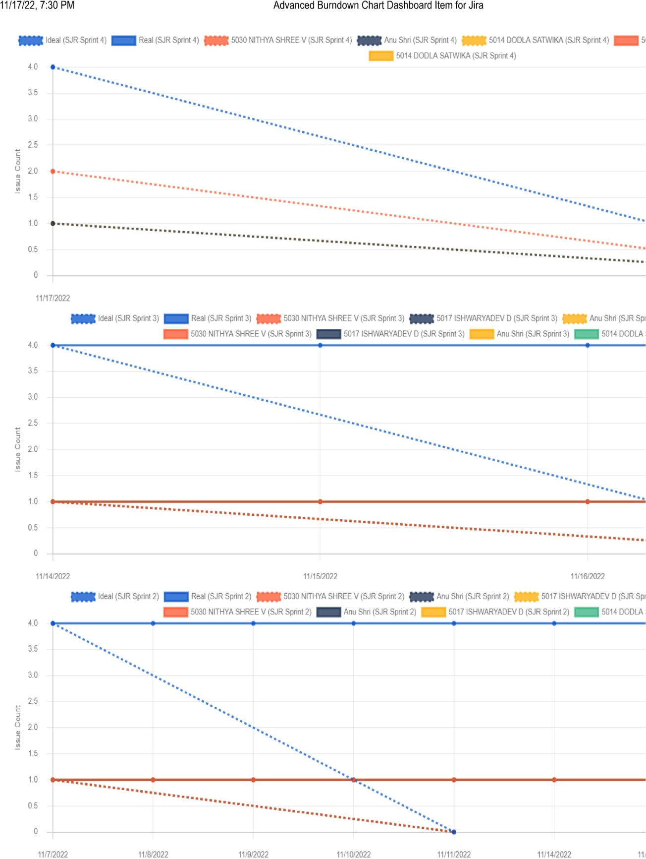

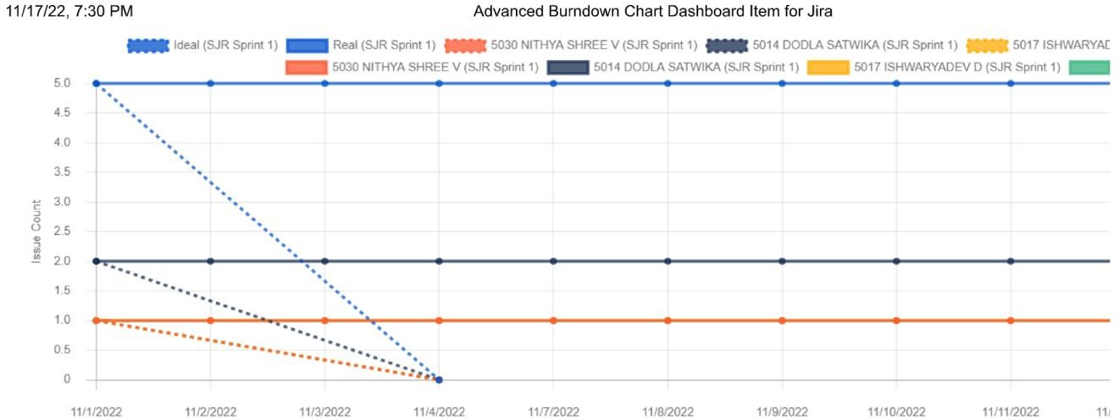

## CODING & SOLUTIONING

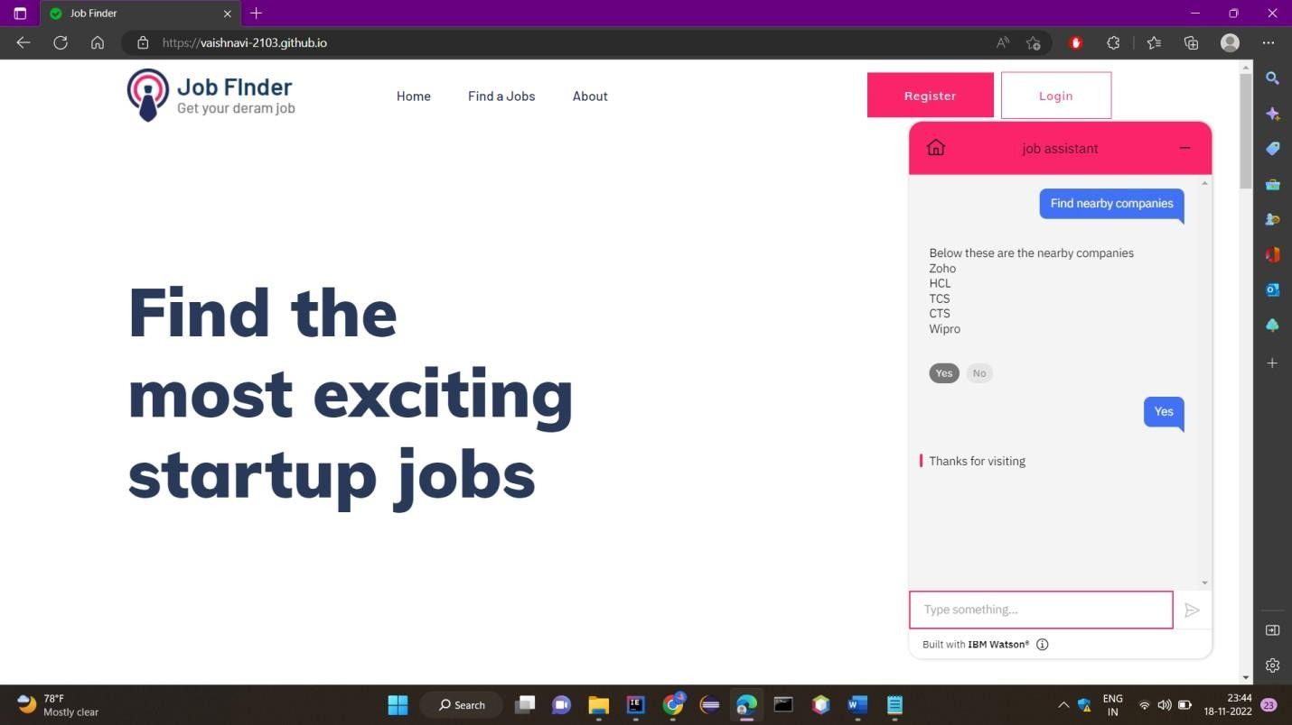**Feature 1**

The software has an In-built “Chat Bot” which can help assist with ongoing queries and provide fast and effective solutions to user problems which may occur and also redirect to management attention if need be there any complications the customer service will be available 24*7 to assist in case of any controversial issues arise

## Feature 2

In this project we have created the dashboard page to view the jobs available and to make ease to access the website

* They communicate information quickly.
* They display information clearly and efficiently.
* They show trends and changes in data over time.
* They are easily customizable.
* The most important widgets and data components are effectively presented in a limited space.

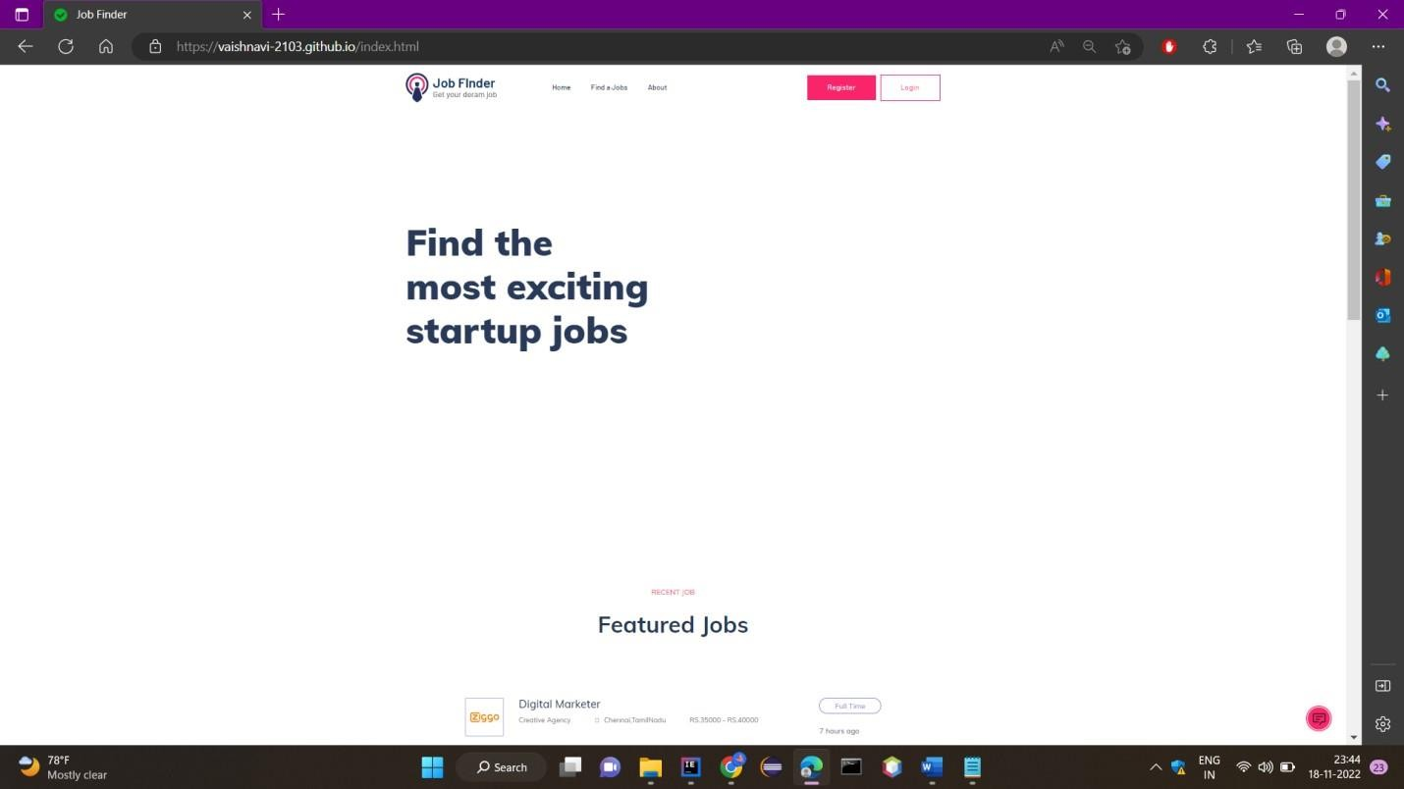

## TESTING

**Test Cases**

Software testing is the process of evaluating and verifying that a software product or application does what it is supposed to do. The benefits of testing include preventing bugs, reducing development costs and improving performance.

## This Software is tested and evaluated successfully.

**User Acceptance Testing**

Purpose of Document

The purpose of this document is to briefly explain the test coverage and open issues of the Inventory Management System project at the time of the release to User Acceptance Testing (UAT)

User Acceptance Testing is carried out in a separate testing environment. A change, an update, or a new feature is requested and developed. Unit and integration tests are run. All seems to be in order. But then, after it is released to the public, serious problems appear. Rework and retesting are not the most expensive consequences when that happens. Loss of reputation is.

## RESULTS

**Performance Metrics**

Based on the two types of user recommendations mentioned above, we analyze the performance of all the techniques mentioned above. The resultant jobs recommended to eachnew user are then checked with the job that the user is originally in as per the test dataset. If the original user job is recommended in the model result, then the model appends 1 for yes else, it appends 0 for no.

This array of 0's and 1's thus received is then checked for accuracy by computing the count of1's from the total user predictions

Among all the models made with the incorporation of different similarity metrics, the cosine similarity based job recommendation system model outperformed rest of

them all. The metrics used to analyse the model performance are: accuracy, precision, recall and F1-score.This is because cosine considers the existence of duplicate terms while computingsimilarity.Also, computationally, cosine has low complexity and ease over handling spare data vectors since only non-zero dimensions are considered.

Upon analyzing the result table we observe that the short-comings of some similarity measures upon recommending top 5 and highest-score based job recommendations as even uponachieving high . similarity scores is due to the fact that users are seen to have different jobs than the ones recommended by the models, thus resulting in 6–10% error rates.

## ADVANTAGES

* The model doesn't need any data about other users, since the recommendations are specific to this user.
* This makes it easier to scale to a large number of users.
* The model can capture the specific interests of a user, and can recommend niche items that very few other users are interested in.

## DISADVANTAGES

* Since the feature representation of the items are hand-engineered to some extent,this technique requires a lot of domain knowledge. Therefore, the model can only be as good as the hand-engineered features.
* The model can only make recommendations based on existing interests of the user.
* In other words, the model has limited ability to expand on the users' existing interests

## CONCLUSION

In this project, Content-Based Filtering and Collaborative Filtering of recommendations have been compared. Additionally, an aggregation plus recommender system has been devised.

Content-Based Filtering recommends the results based on matching the personal preferencesof the user with the given document whereas collaborative filtering recommends based on thepreferences of fellow users. On evaluating both of these methods, it was concluded that a hybrid system of both of these overcomes the limitations of both of them and increases the efficiency of ranking. Problems of cold start, sparse database, scalability, and lack of trend recommendation have been eliminated. The proposal is to design a Job recommender system that prioritizes quality over quantity. While there are websites and job listing portals already recommending jobs to job seekers based on their profiles, this research on aggregate quality recommendations has been achieved by crawling selectively, overcoming thelimitations. A fully functioning user interface was developed to combine everything togetherto give the user a seamless experience.

## FUTURE SCOPE

Future works in the case of Personalized Job Recommendation Systems are the utilization of the user-preferred location to get job recommendations based on jobs in organizations established in nearby areas. This can be done by extracting the latitudes andlongitudes of the user-preferred location and computing the euclidean distances between the latitudes and longitudes of the organization location.

As part of the future work, we plan to use features of similar candidates and jobs in sequence information. As of now, recommendation using similar candidates an jobs forms part of non-machine learning based recommendations and the initial result seem promising.Finally, it would be interesting to extend our methodology to other recommender system.

## APPENDIX

**Source Code**

|  |
| --- |
| <!DOCtype html>  <html class="no-js" lang="zxx"> |
| <head> |
| <meta charset="utf-8"> |
| <meta http-equiv="x-ua-compatible" content="ie=edge"> |
| <title>Job Finder</title> |
| <meta name="description" content=""> |
| <meta name="viewport" content="width=device-width, initial-scale=1"> |
| <link rel="manifest" href="site.webmanifest"> |
| <link rel="shortcut icon" type="image/x-icon" href="[http://s3.jp-](http://s3.jp-/)  tok.cloud-object-storage.appdomain.cloud/jobportalwebsite/assets/img/favicon.ico"> |
| <link rel="stylesheet" href="[http://s3.jp-tok.cloud-object-](http://s3.jp-tok.cloud-object-/)  storage.appdomain.cloud/jobportalwebsite/assets/css/bootstrap.min.css"> |
| <link rel="stylesheet" href="[http://s3.jp-tok.cloud-object-](http://s3.jp-tok.cloud-object-/)  storage.appdomain.cloud/jobportalwebsite/assets/css/owl.carousel.min.css"> |
| <link rel="stylesheet" href="[http://s3.jp-tok.cloud-object-](http://s3.jp-tok.cloud-object-/)  storage.appdomain.cloud/jobportalwebsite/assets/css/flaticon.css"> |
| <link rel="stylesheet" href="[http://s3.jp-tok.cloud-object-](http://s3.jp-tok.cloud-object-/) storage.appdomain.cloud/jobportalwebsite/assets/css/price_rangs.css"> |

|  |
| --- |
| <link rel="stylesheet" href="[http://s3.jp-tok.cloud-object-](http://s3.jp-tok.cloud-object-/)  storage.appdomain.cloud/jobportalwebsite/assets/css/slicknav.css"> |
| <link rel="stylesheet" href="[http://s3.jp-tok.cloud-object-](http://s3.jp-tok.cloud-object-/)  storage.appdomain.cloud/jobportalwebsite/assets/css/animate.min.css"> |
| <link rel="stylesheet" href="[http://s3.jp-tok.cloud-object-](http://s3.jp-tok.cloud-object-/)  storage.appdomain.cloud/jobportalwebsite/assets/css/magnific-popup.css"> |
| <link rel="stylesheet" href="[http://s3.jp-tok.cloud-object-](http://s3.jp-tok.cloud-object-/)  storage.appdomain.cloud/jobportalwebsite/assets/css/fontawesome-all.min.css"> |
| <link rel="stylesheet" href="[http://s3.jp-tok.cloud-object-](http://s3.jp-tok.cloud-object-/)  storage.appdomain.cloud/jobportalwebsite/assets/css/themify-icons.css"> |
| <link rel="stylesheet" href="[http://s3.jp-tok.cloud-object-](http://s3.jp-tok.cloud-object-/)  storage.appdomain.cloud/jobportalwebsite/assets/css/slick.css"> |
| <link rel="stylesheet" href="[http://s3.jp-tok.cloud-object-](http://s3.jp-tok.cloud-object-/)  storage.appdomain.cloud/jobportalwebsite/assets/css/nice-select.css"> |
| <link rel="stylesheet" href="[http://s3.jp-tok.cloud-object-](http://s3.jp-tok.cloud-object-/)  storage.appdomain.cloud/jobportalwebsite/assets/css/style.css"> |
| <body> |
| <header> |
| <!-- Header Start --> |
| <div class="header-area header-transparrent"> |
| <div class="headder-top header-sticky"> |
| <div class="container"> |
| <div class="row align-items-center"> |
| <div class="col-lg-3 col-md-2"> |
| <!-- Logo --> |
| <div class="logo"> |
| <a href="index.html"><img src="[http://s3.jp-tok.cloud-object-](http://s3.jp-tok.cloud-object-/)  storage.appdomain.cloud/jobportalwebsite/assets/img/logo/logo.png" alt=""></a> |
| </div> |
| </div> |
| <div class="col-lg-9 col-md-9"> |
| <div class="menu-wrapper"> |
| <!-- Main-menu --> |
| <div class="main-menu"> |
| <nav class="d-none d-lg-block"> |
| <ul id="navigation"> |
| <li><a href="/index">Home</a></li> |
| <li><a href="/job_listing">Find a Jobs </a></li> |
| <li><a href="/about">About</a></li> |
| </ul> |
| </nav> |

|  |
| --- |
| </div> |
| <!-- Header-btn --> |
| <div class="header-btn d-none f-right d-lg-block"> |
| <a href="/registeration" class="btn head-btn1">Register</a> |
| <a href="/login" class="btn head-btn2">Login</a> |
| </div> |
| </div> |
| </div> |
| <!-- Mobile Menu --> |
| <div class="col-12"> |
| <div class="mobile_menu d-block d-lg-none"></div> |
| </div> |
| </div> |
| </div> |
| </div> |
| </div> |
| <!-- Header End --> |
| </header> |
| <main> |
| <!-- slider Area Start--> |
| <div class="slider-area "> |
| <!-- Mobile Menu --> |
| <div class="slider-active"> |
| <div class="single-slider slider-height d-flex align-items-center" data-  background="[http://s3.jp-tok.cloud-object-](http://s3.jp-tok.cloud-object-/) storage.appdomain.cloud/jobportalwebsite/assets/img/hero/h1_hero.jpg"> |
| <div class="container"> |
| <div class="row"> |
| <div class="col-xl-6 col-lg-9 col-md-10"> |
| <div class="hero caption"> |
| <h1>Find the most exciting startup jobs</h1> |
| </div> |
| </div> |
| </div> |
| </div> |
| </div> |
| </div> |
| </div> |
| <!-- slider Area End--> |
| <!-- Featured_job_start --> |
| <section class="featured-job-area feature-padding"> |

|  |
| --- |
| <div class="container"> |
| <!-- Section Tittle --> |
| <div class="row"> |
| <div class="col-lg-12"> |
| <div class="section-tittle text-center"> |
| <span>Recent Job</span> |
| <h2>Featured Jobs</h2> |
| </div> |
| </div> |
| </div> |
| <div class="row justify-content-center"> |
| <div class="col-xl-10"> |
| <!-- single-job-content --> |
| <div class="single-job-items mb-30"> |
| <div class="job-items"> |
| <div class="company-img"> |
| <a href="#"><img src="[http://s3.jp-tok.cloud-object-](http://s3.jp-tok.cloud-object-/)  storage.appdomain.cloud/jobportalwebsite/assets/img/icon/job-list1.png" alt="img"></a> |
| </div> |
| <div class="job-tittle job-tittle2"> |
| <a href="#"> |
| <h4>Digital Marketer</h4> |
| </a> |
| <ul> |
| <li>Creative Agency</li> |
| <li><i class="fas fa-map-marker-  alt"></i>Chennai,TamilNadu</li> |
| <li>RS.35000 - RS.40000</li> |
| </ul> |
| </div> |
| </div> |
| <div class="items-link items-link2 f-right"> |
| <a href="/job_details">Full Time</a> |
| <span>7 hours ago</span> |
| </div> |
| </div> |
| <!-- single-job-content --> |
| <div class="single-job-items mb-30"> |
| <div class="job-items"> |
| <div class="company-img"> |
| <a href="#"><img src="[http://s3.jp-tok.cloud-object-](http://s3.jp-tok.cloud-object-/)  storage.appdomain.cloud/jobportalwebsite/assets/img/icon/job-list2.png" alt="img"></a> |
| </div> |

|  |
| --- |
| <div class="job-tittle job-tittle2"> |
| <a href="#"> |
| <h4>Back End Developer</h4> |
| </a> |
| <ul> |
| <li>Mentee Chain</li> |
| <li><i class="fas fa-map-marker-  alt"></i>Chennai,TamilNadu</li> |
| <li>RS.41500 - RS.72000</li> |
| </ul> |
| </div> |
| </div> |
| <div class="items-link items-link2 f-right"> |
| <a href="/job_details">Full Time</a> |
| <span>5 hours ago</span> |
| </div> |
| </div> |
| <!-- single-job-content --> |
| <div class="single-job-items mb-30"> |
| <div class="job-items"> |
| <div class="company-img"> |
| <a href="#"><img src="[http://s3.jp-tok.cloud-object-](http://s3.jp-tok.cloud-object-/)  storage.appdomain.cloud/jobportalwebsite/assets/img/icon/job-list3.png" alt=""></a> |
| </div> |
| <div class="job-tittle job-tittle2"> |
| <a href="#"> |
| <h4>SQL Developer</h4> |
| </a> |
| <ul> |
| <li>Sutherland</li> |
| <li><i class="fas fa-map-marker-  alt"></i>Chennai,TamilNadu</li> |
| <li>RS.82500 - RS.44000</li> |
| </ul> |
| </div> |
| </div> |
| <div class="items-link items-link2 f-right"> |
| <a href="/job_details">Full Time</a> |
| <span>2 hours ago</span> |
| </div> |
| </div> |
| <!-- single-job-content --> |
| <div class="single-job-items mb-30"> |

|  |
| --- |
| <div class="job-items"> |
| <div class="company-img"> |
| <a href="#"><img src="[http://s3.jp-tok.cloud-object-](http://s3.jp-tok.cloud-object-/)  storage.appdomain.cloud/jobportalwebsite/assets/img/icon/job-list4.png" alt=""></a> |
| </div> |
| <div class="job-tittle job-tittle2"> |
| <a href="#"> |
| <h4>TIBCO Developer</h4> |
| </a> |
| <ul> |
| <li>Infosys</li> |
| <li><i class="fas fa-map-marker-  alt"></i>Chennai,TamilNadu</li> |
| <li>RS.53500 - RS.40000</li> |
| </ul> |
| </div> |
| </div> |
| <div class="items-link items-link2 f-right"> |
| <a href="/job_details">Full Time</a> |
| <span>1 hours ago</span> |
| </div> |
| </div> |
| <!-- single-job-content --> |
| <div class="single-job-items mb-30"> |
| <div class="job-items"> |
| <div class="company-img"> |
| <a href="#"><img src="[http://s3.jp-tok.cloud-object-](http://s3.jp-tok.cloud-object-/)  storage.appdomain.cloud/jobportalwebsite/assets/img/icon/job-list1.png" alt=""></a> |
| </div> |
| <div class="job-tittle job-tittle2"> |
| <a href="#"> |
| <h4>Hadoop Developer</h4> |
| </a> |
| <ul> |
| <li>Capgemini</li> |
| <li><i class="fas fa-map-marker-  alt"></i>Chennai,TamilNadu</li> |
| <li>RS.33500 - RS.24000</li> |
| </ul> |
| </div> |
| </div> |
| <div class="items-link items-link2 f-right"> |
| <a href="/job_details">Full Time</a> |

|  |
| --- |
| <span>3 hours ago</span> |
| </div> |
| </div> |
| <!-- single-job-content --> |
| <div class="single-job-items mb-30"> |
| <div class="job-items"> |
| <div class="company-img"> |
| <a href="#"><img src="[http://s3.jp-tok.cloud-object-](http://s3.jp-tok.cloud-object-/)  storage.appdomain.cloud/jobportalwebsite/assets/img/icon/job-list3.png" alt=""></a> |
| </div> |
| <div class="job-tittle job-tittle2"> |
| <a href="#"> |
| <h4>Full stack Developer</h4> |
| </a> |
| <ul> |
| <li>VCW Limited</li> |
| <li><i class="fas fa-map-marker-  alt"></i>Chennai,TamilNadu</li> |
| <li>RS.45500 - RS.24000</li> |
| </ul> |
| </div> |
| </div> |
| <div class="items-link items-link2 f-right"> |
| <a href="/job_details">Full Time</a> |
| <span>4 hours ago</span> |
| </div> |
| </div> |
| <!-- single-job-content --> |
| <div class="single-job-items mb-30"> |
| <div class="job-items"> |
| <div class="company-img"> |
| <a href="#"><img src="[http://s3.jp-tok.cloud-object-](http://s3.jp-tok.cloud-object-/)  storage.appdomain.cloud/jobportalwebsite/assets/img/icon/job-list4.png" alt=""></a> |
| </div> |
| <div class="job-tittle job-tittle2"> |
| <a href="#"> |
| <h4>Senior FinOps Engineer</h4> |
| </a> |
| <ul> |
| <li>WPP</li> |
| <li><i class="fas fa-map-marker-  alt"></i>Chennai,TamilNadu</li> |
| <li>RS.33500 - RS54000</li> |

|  |
| --- |
| </ul> |
| </div> |
| </div> |
| <div class="items-link items-link2 f-right"> |
| <a href="/job_details">Full Time</a> |
| <span>6 hours ago</span> |
| </div> |
| </div> |
| </div> |
| </section> |
| <!-- Featured_job_end --> |
| <!-- How Apply Process Start--> |
| <div class="apply-process-area apply-bg pt-150 pb-150" data-  background="[http://s3.jp-tok.cloud-object-](http://s3.jp-tok.cloud-object-/) storage.appdomain.cloud/jobportalwebsite/assets/img/gallery/how-applybg.png"> |
| <div class="container"> |
| <!-- Section Tittle --> |
| <div class="row"> |
| <div class="col-lg-12"> |
| <div class="section-tittle white-text text-center"> |
| <span>Apply process</span> |
| <h2> How it works</h2> |
| </div> |
| </div> |
| </div> |
| <!-- Apply Process Caption --> |
| <div class="row"> |
| <div class="col-lg-4 col-md-6"> |
| <div class="single-process text-center mb-30"> |
| <div class="process-ion"> |
| <span class="flaticon-search"></span> |
| </div> |
| <div class="process-cap"> |
| <h5>1. Search a job</h5> |
| <p></p> |
| </div> |
| </div> |
| </div> |
| <div class="col-lg-4 col-md-6"> |
| <div class="single-process text-center mb-30"> |
| <div class="process-ion"> |
| <span class="flaticon-curriculum-vitae"></span> |
| </div> |

|  |
| --- |
| <div class="process-cap"> |
| <h5>2. Apply for job</h5> |
| <p></p> |
| </div> |
| </div> |
| </div> |
| <div class="col-lg-4 col-md-6"> |
| <div class="single-process text-center mb-30"> |
| <div class="process-ion"> |
| <span class="flaticon-tour"></span> |
| </div> |
| <div class="process-cap"> |
| <h5>3. Get your job</h5> |
| <p></p> |
| </div> |
| </div> |
| </div> |
| </div> |
| </div> |
| </div> |
| <!-- How Apply Process End--> |
| </main> |
| <footer> |
| <!-- Footer Start--> |
| <div class="footer-area footer-bg footer-padding"> |
| <div class="container"> |
| <div class="row d-flex justify-content-between"> |
| <div class="col-xl-3 col-lg-3 col-md-4 col-sm-6"> |
| <div class="single-footer-caption mb-50"> |
| <div class="single-footer-caption mb-30"> |
| <div class="footer-tittle"> |
| <h4>About Us</h4> |
| <div class="footer-pera"> |
| <p> Connect the world’s professionals to make them more productive and successful.</p> |
| </div> |
| </div> |
| </div> |
| </div> |
| </div> |
| <div class="col-xl-3 col-lg-3 col-md-4 col-sm-5"> |

|  |
| --- |
| <div class="single-footer-caption mb-50"> |
| <div class="footer-tittle"> |
| <h4>Contact Info</h4> |
| <ul> |
| <li> |
| <p>Address :<br> |
| 2, jobfinds ltd, |
| <br> |
| Anna Nagar, |
| <br>madurai</p> |
| </li> |
| <li><a href="#">Phone : +99999 99999</a></li> |
| <li><a href="#">Email : [info@jobfinder.com</a](mailto:info@jobfinder.com)></li> |
| </ul> |
| </div> |
| </div> |
| </div> |
| <!-- footer-bottom area --> |
| <div class="footer-bottom-area footer-bg"> |
| <div class="container"> |
| <div class="footer-border"> |
| <div class="row d-flex justify-content-between align-items-center"> |
| <div class="col-xl-10 col-lg-10 "> |
| <div class="footer-copy-right"> |
| <p> |
| Copyright &copy;<script>document.write(new Date().getFullYear());</script> All  rights reserved |
| </p> |
| </div> |
| </div> |
| </div> |
| </div> |
| </div> |
| </div> |
| </div> |
| </div> |
| </div> |
| <!-- Footer End--> |
| </footer> |
| <!-- JS here --> |

|  |
| --- |
| <!-- All JS Custom Plugins Link Here here --> |
| <script src="[http://s3.jp-tok.cloud-object-](http://s3.jp-tok.cloud-object-/)  storage.appdomain.cloud/jobportalwebsite/assets/js/vendor/modernizr- 3.5.0.min.js"></script> |
| <!-- Jquery, Popper, Bootstrap --> |
| <script src="[http://s3.jp-tok.cloud-object-](http://s3.jp-tok.cloud-object-/)  storage.appdomain.cloud/jobportalwebsite/assets/js/vendor/jquery- 1.12.4.min.js"></script> |
| <script src="[http://s3.jp-tok.cloud-object-](http://s3.jp-tok.cloud-object-/)  storage.appdomain.cloud/jobportalwebsite/assets/js/popper.min.js"></script> |
| <script src="[http://s3.jp-tok.cloud-object-](http://s3.jp-tok.cloud-object-/)  storage.appdomain.cloud/jobportalwebsite/assets/js/bootstrap.min.js"></script> |
| <!-- Jquery Mobile Menu --> |
| <script src="[http://s3.jp-tok.cloud-object-](http://s3.jp-tok.cloud-object-/)  storage.appdomain.cloud/jobportalwebsite/assets/js/jquery.slicknav.min.js"></script> |
| <!-- Jquery Slick , Owl-Carousel Plugins --> |
| <script src="[http://s3.jp-tok.cloud-object-](http://s3.jp-tok.cloud-object-/)  storage.appdomain.cloud/jobportalwebsite/assets/js/owl.carousel.min.js"></script> |
| <script src="[http://s3.jp-tok.cloud-object-](http://s3.jp-tok.cloud-object-/)  storage.appdomain.cloud/jobportalwebsite/assets/js/slick.min.js"></script> |
| <script src="[http://s3.jp-tok.cloud-object-](http://s3.jp-tok.cloud-object-/)  storage.appdomain.cloud/jobportalwebsite/assets/js/price_rangs.js"></script> |
| <!-- One Page, Animated-HeadLin --> |
| <script src="[http://s3.jp-tok.cloud-object-](http://s3.jp-tok.cloud-object-/)  storage.appdomain.cloud/jobportalwebsite/assets/js/wow.min.js"></script> |
| <script src="[http://s3.jp-tok.cloud-object-](http://s3.jp-tok.cloud-object-/)  storage.appdomain.cloud/jobportalwebsite/assets/js/animated.headline.js"></script> |
| <script src="[http://s3.jp-tok.cloud-object-](http://s3.jp-tok.cloud-object-/)  storage.appdomain.cloud/jobportalwebsite/assets/js/jquery.magnific-popup.js"></script> |
| <!-- Scrollup, nice-select, sticky --> |
| <script src="[http://s3.jp-tok.cloud-object-](http://s3.jp-tok.cloud-object-/)  storage.appdomain.cloud/jobportalwebsite/assets/js/jquery.scrollUp.min.js"></script> |
| <script src="[http://s3.jp-tok.cloud-object-](http://s3.jp-tok.cloud-object-/)  storage.appdomain.cloud/jobportalwebsite/assets/js/jquery.nice-select.min.js"></script> |
| <script src="./assets/js/jquery.sticky.js"></script> |
| <!-- contact js --> |
| <script src="[http://s3.jp-tok.cloud-object-](http://s3.jp-tok.cloud-object-/)  storage.appdomain.cloud/jobportalwebsite/assets/js/contact.js"></script> |
| <script src="[http://s3.jp-tok.cloud-object-](http://s3.jp-tok.cloud-object-/)  storage.appdomain.cloud/jobportalwebsite/assets/js/jquery.form.js"></script> |
| <script src="[http://s3.jp-tok.cloud-object-](http://s3.jp-tok.cloud-object-/) |

|  |
| --- |
| storage.appdomain.cloud/jobportalwebsite/assets/js/jquery.validate.min.js"></script> |
| <script src="[http://s3.jp-tok.cloud-object-](http://s3.jp-tok.cloud-object-/)  storage.appdomain.cloud/jobportalwebsite/assets/js/mail-script.js"></script> |
| <script src="[http://s3.jp-tok.cloud-object-](http://s3.jp-tok.cloud-object-/) storage.appdomain.cloud/jobportalwebsite/assets/js/jquery.ajaxchimp.min.js"></script> |
| <!-- Jquery Plugins, main Jquery --> |
| <script src="[http://s3.jp-tok.cloud-object-](http://s3.jp-tok.cloud-object-/)  storage.appdomain.cloud/jobportalwebsite/assets/js/plugins.js"></script> |
| <script src="[http://s3.jp-tok.cloud-object-](http://s3.jp-tok.cloud-object-/) storage.appdomain.cloud/jobportalwebsite/assets/js/main.js"></script> |
| <script> |
| window.watsonAssistantChatOptions = { |
| integrationID: "65c01ed6-9fc1-4883-979a-3676279ebe44", // The ID of this  integration. |
| region: "us-south", // The region your integration is hosted in. |
| serviceInstanceID: "8fcd017f-a192-420a-aafc-18cb0330efca", // The ID of your  service instance. |
| onLoad: function(instance) { instance.render(); } |
| }; |
| setTimeout(function(){ |
| const t=document.createElement('script'); |
| t.src="https://web-chat.global.assistant.watson.appdomain.cloud/versions/" +  (window.watsonAssistantChatOptions.clientVersion || 'latest') + "/WatsonAssistantChatEntry.js"; |
| document.head.appendChild(t); |
| }); |
| </script> |
| </body> |
| </html> |

## GitHub Link :

**https://github.com/IBM-EPBL/IBM-Project-34737-1660275704**